**Email**:

No doubt you’ve heard of the changes coming to our economy. If you have, you’re likely worried sick about how our country will survive.

But according to [this financial expert](https://secure.empirefinancialresearch.com/?cid=MKT450682&eid=MKT557483), these changes don’t have to ruin us.

In fact, if Americans invest now, we could find ourselves with the best real estate market we’ve ever seen, energy, insurance, and healthcare industries growing like crazy, and even an extra $6,000 richer every year.

Want to find out more and learn how to take advantage of this incredible investment opportunity? [Click here](https://secure.empirefinancialresearch.com/?cid=MKT450682&eid=MKT557483).

Don’t wait another minute to write your name in the [most important investment story of 2021](https://secure.empirefinancialresearch.com/?cid=MKT450682&eid=MKT557483).

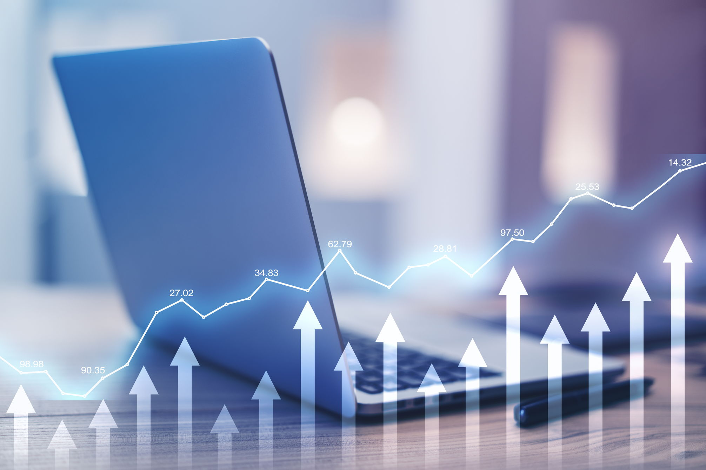

**Subject Lines:**

The World’s NEWEST Richest Man…

The World Has NEW Richest Man